**Dr. Tarannum Sarwat**

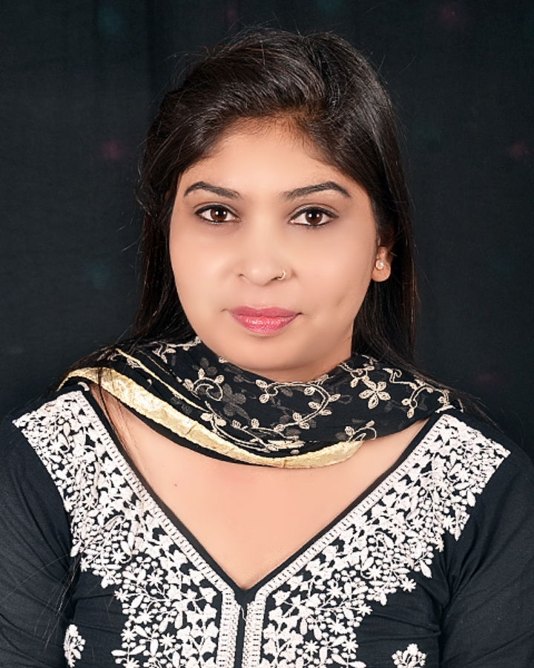

Guest Faculty in Sociology,

Department of Sociology,

Govt. Tutsi College (G.T.C.)

Anuppur(M.P.)- 484224

Mobile No: 9131772451

e-Mail: [khansimran785@mail.com](mailto:khansimran785@mail.com)

* **Personal Details:**

Date of Birth: 29/10/1988 Gender: Female

Marital Status: Unmarried Language: Hindi& English

**Family Background :**

**Father Name :** Late Shahabuddin Khan (Retd. Engineer PWD)

**Mother Name :** Najma Begum (housewife)

**Achievment in Student Life :** President of Student Union (ABVP)

**Award** : Jan Jagaran Sewa Samman (2019)

Virat Srijan Samman (2015)

* **Educational Qualification:**
* ***Ph.D. (2020)*** on the topic ***“परम्परागत उद्योग एवं जनजातीय जीवन में परिवर्तन: एक समाजशास्त्रीय अध्ययन(मध्य प्रदेश राज्य के अनूपपुर जिले के गोंड एवं बैगा जनजाति के सन्दर्भ में)”*** From Rani Durgawati University of Jabalpur in the Subject of Sociology .
* ***Master of Arts in Sociology*** from APS University with First Division (2010).
* Bachelor of Arts in ***History, Political Science, Economics*** from PAS University,Rewa with Second Division (2008).
* ***Intermediate in History, Political Science, Economics*** from MP Board Bhopal in Second Division (2005).
* ***High School*** in All Subjects from MP Board Bhopal in Second Division (2002).
* **Specialization and Additional Academic Exposure:**
* Specialization in ***MSW*** (Master of Social Work) MP Bhoj Open University Bhopal (2012).
* One Year Certificate in ***Diploma in Computer Application (DCA)*** MLCN University Bhopal (2008).
* ***Counselor, Rural Development Program*** (RDP) course of IGNOU at GTC.
* **Teaching Experiences:**

From year 2012 to till date.

Papers Taught: (BA/MA) Sociology.

***Area of interest***: Theoretical Perspective in Sociology, Sociology of Change & Development, Political Sociology, Social Demography.

**Research:**

***Publications:***

2014

* A research Paper has been Published entitled “***कोल जनजाति की महिलाओं में स्वास्थ संबंधी समस्याएं(ग्राम पंचायत गुढ़ जिला रीवा के विशेष सन्दर्भ में)”***  ISSN: 2347-5838 January-December -2014

2018

* A research Paper has been Published entitled “***अनूपपुर जिले में बाल श्रमिकों की पारिवारिक समस्याओं का अध्ययन”*** ISSUE No. 3 Vol.-III, ISSN 2320- 351X, Impact Factor 2.836 September 2018.
* A research Paper has been Published entitled ***“परम्परागत उद्योग एवं जनजातीय जीवन में परिवर्तन: एक समाजशास्त्रीय अध्ययन(मध्य प्रदेश राज्य के अनूपपुर जिले के गोंड एवं बैगा जनजाति के सन्दर्भ में)”*** Proudest USA (Title ID: 715205) ISSU NO. X XVI- III fgUnh laLdj.k ISSN 0973-3914 December 2018.

2019

* A research Paper has been Published entitled ***“जनजातीय क्षेत्र की महिलाओं में परिवार नियोजन कार्यक्रम के प्रभाव का अध्ययन (अनूपपुर जनपद पंचायत के विशेष सन्दर्भ में)”*** Issue No. 1 Vol. IV ISSU 2230-8938 Impact Factor. 373, January, 2019.
* ***Participation in Webinar amid Lockdown:***
* Participated in a one day National Webinar on ***गाँधी: आत्म-निर्भर भारत*** organized by Department of Political Science Shyama Prasad Mukherjee Government Post Graduate College held on June 6th day of June 2020.
* Participated in a one day National Webinar on ***कोविड-19 और प्रवासी मजदूर*** on June 12th, 2020.
* Participated in a one day National Webinar ***on “Effects on the Study of Mental Stress during Covid-19”*** Organized by Education Department R.D.V.V. Jabalpur Held on 7 July 2020.
* Participated in a one day National Webinar on “Present Scenario and Dissensions of Higher Education in Rural Areas” Held on 7 July 2020. Organized by Govt. College Bhainsdehi Dist. Betul (m .p
* Participated in a one day National Webinar on ***“Re-emergence of Russia in the Contemporary Global or deer.”*** Organized by the Department of Political Science of Human /rights Indian Gandhi National Tribal University, Amarkantak (M.P.) on 8th July 2020.
* Participated in the International Webinar Series Organized by VIDHI BHAWANA FOUNDAION on the Topic ***“Covid-19 Perspective: Emerging Trends of a New Society vis-à-vis Sustainable Development”*** on 25/08/2020.

**Declaration:**

I Hereby Declare That All The Statements Made Above Are Correct To The Best My Knowledge And Belief.

Date :

Place: **Dr. Tarannum Sarwat**